**AWS FACE DETECTION PROJECT**

**DASHBOARDS**

AWS LOGIN SCREEN WITH USERNAME:-

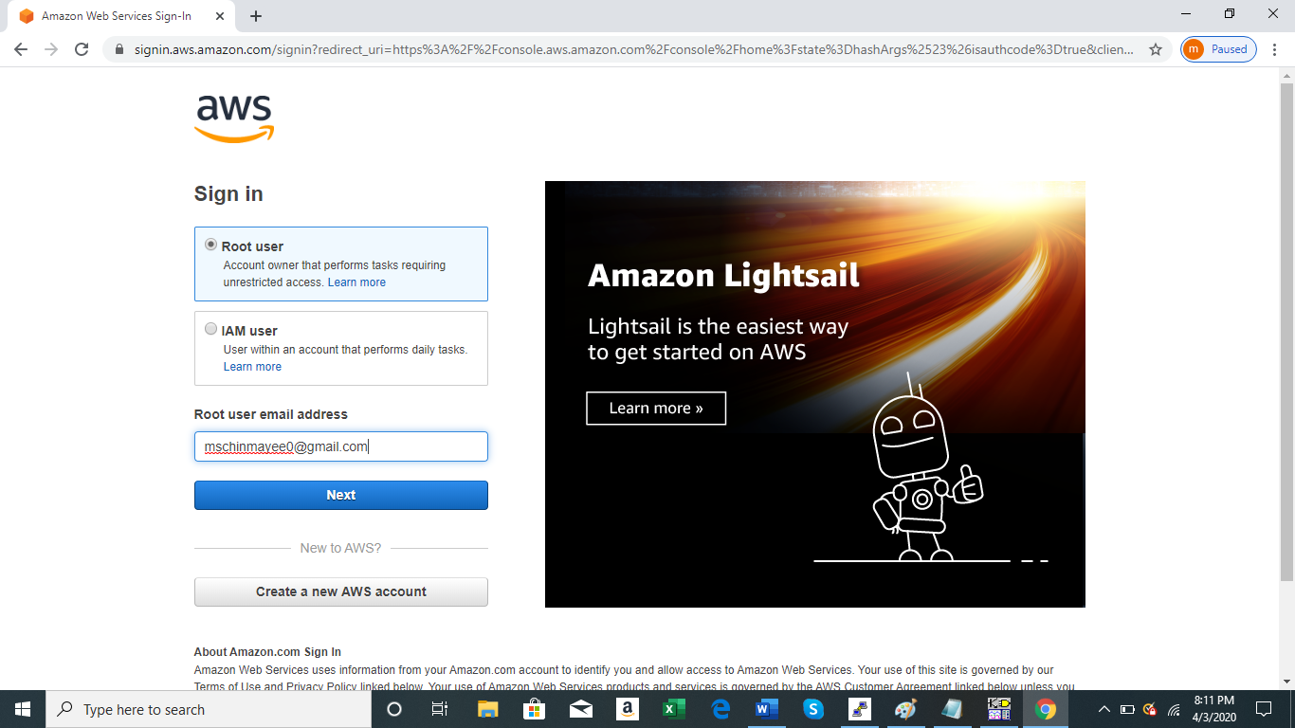

EC2 DASHBOARD:-

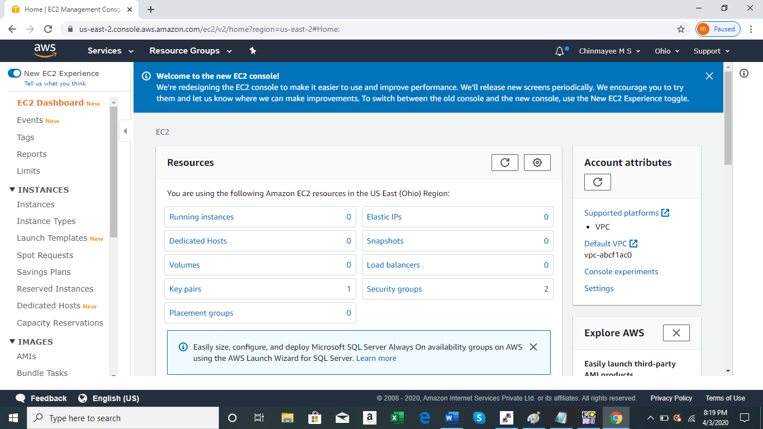

S3 DASHBOARD:-

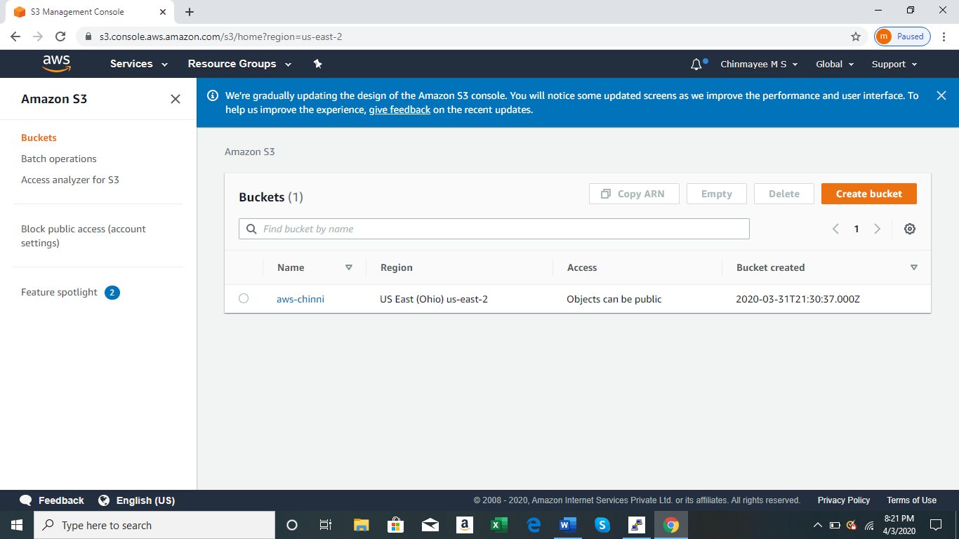

REKOGNITION DASHBOARD:-

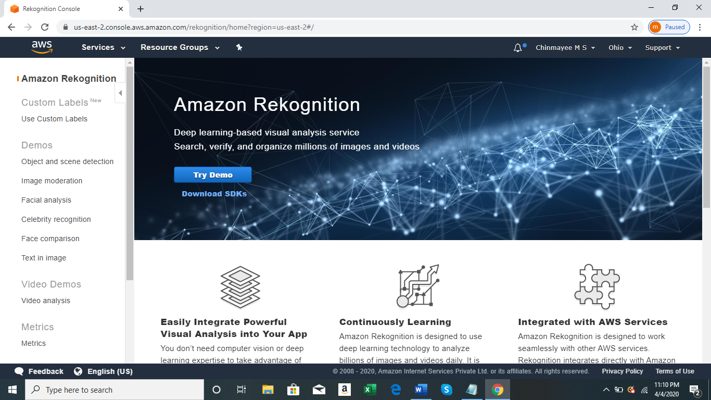

**EC2**

CHOOSING AN AMI:-

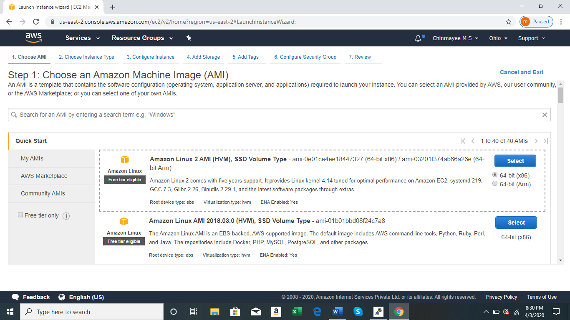

CHOOSING AN INSTANCE TYPE:-

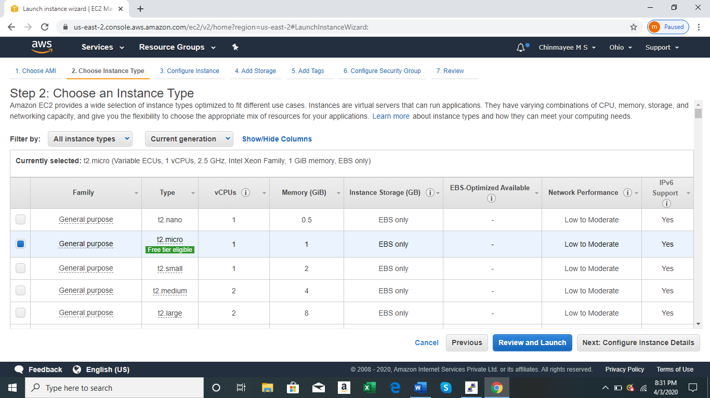

ADDING STORAGE:-

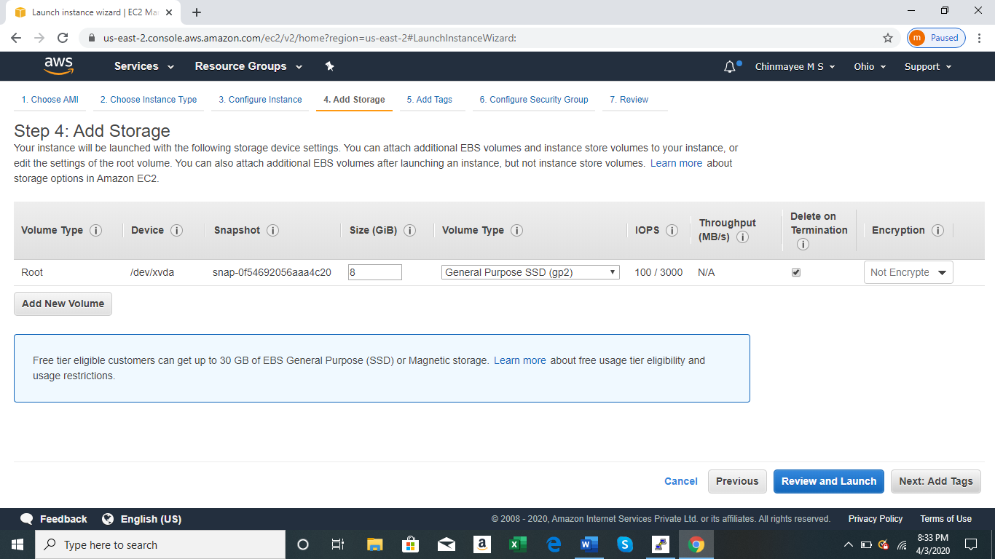

CONFIGURING SECURITY GROUP:-

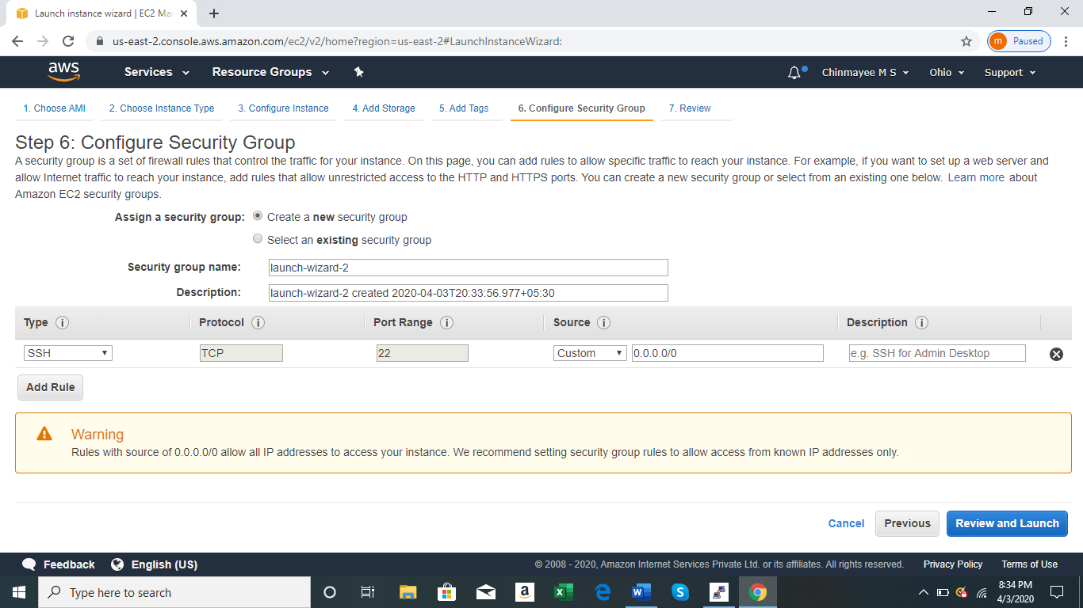

KEY PAIR DOWNLOAD:-

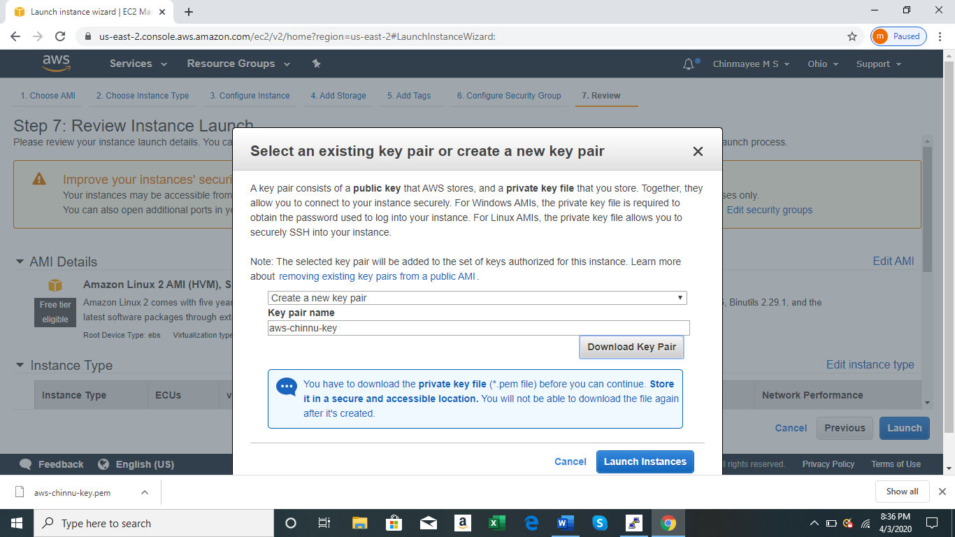

PuTTYgen CONVERSION FROM PEM TO PPK:-

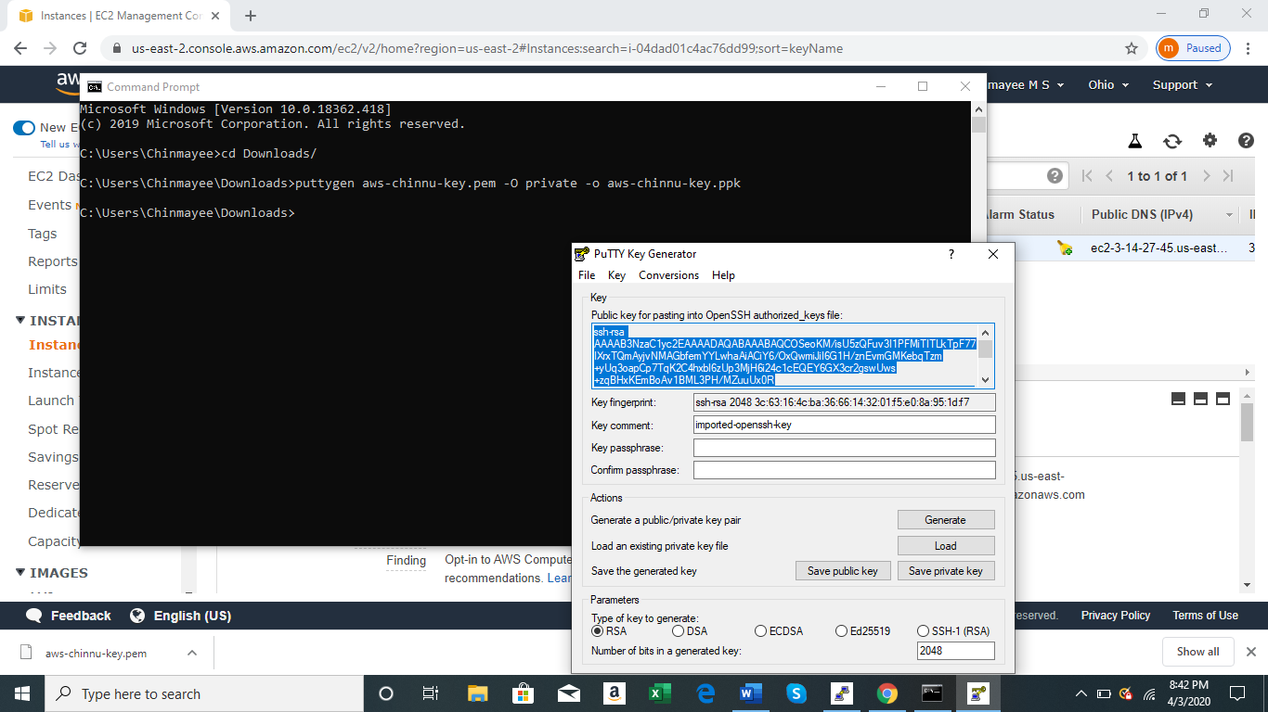

LOGGED IN EC2 BLACK SCREEN:-

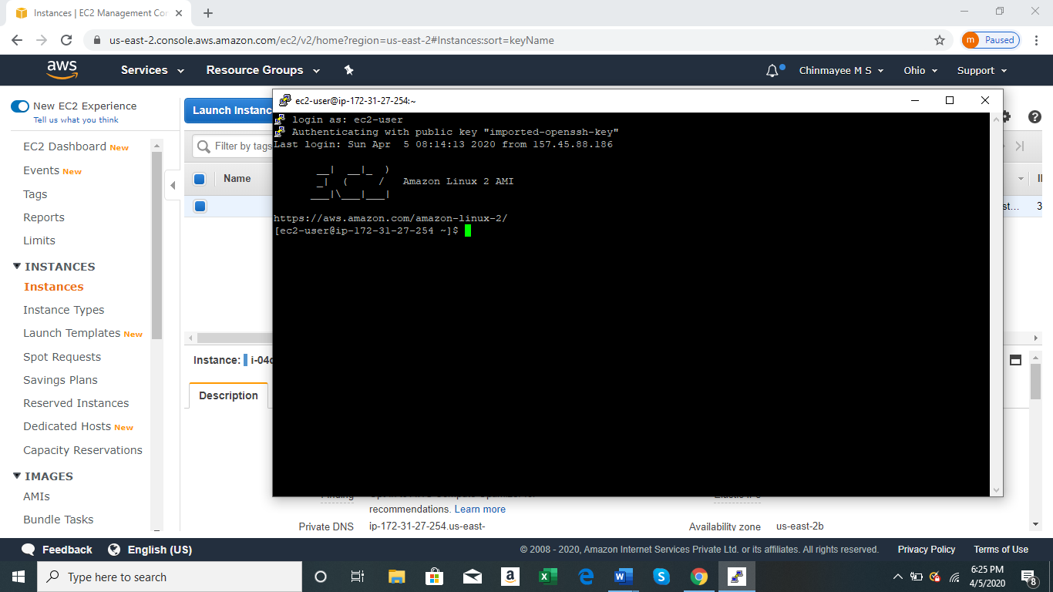

S3

CREATING AN NEW BUCKET:-

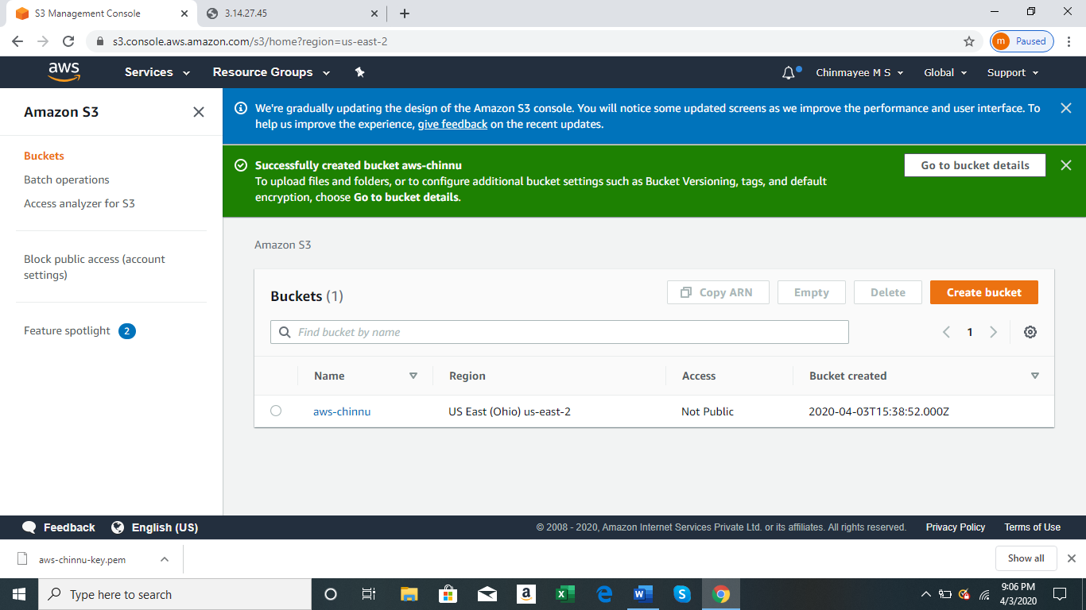

UPLOADING AN OBJECT:-

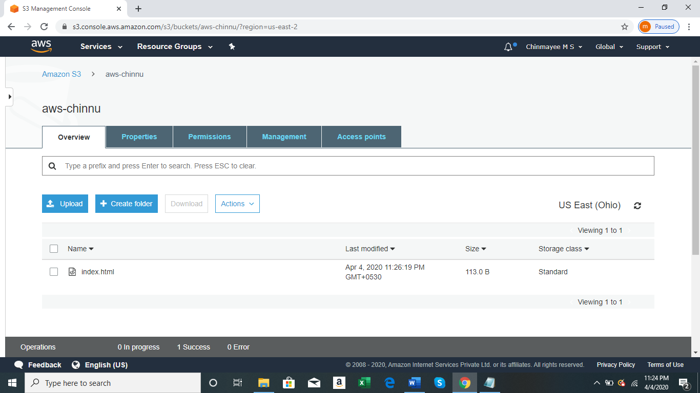

ENABLING STATIC WEBSITE:-

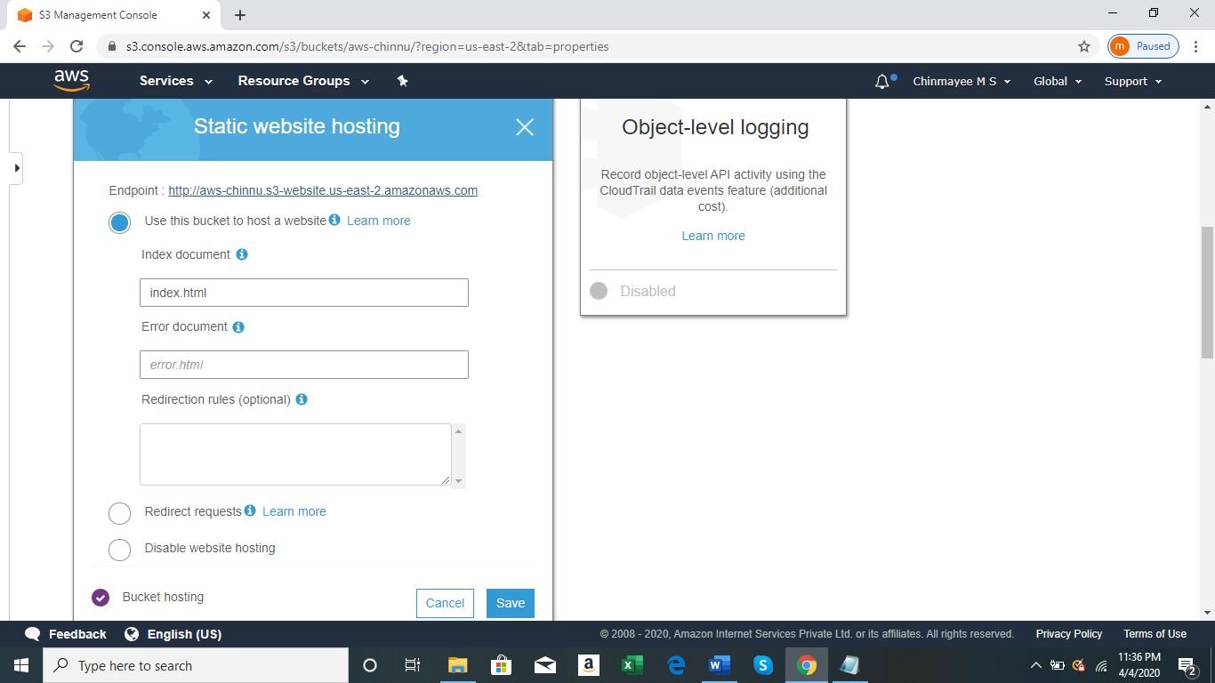

MAKING THE OBJECT PUBLIC:-

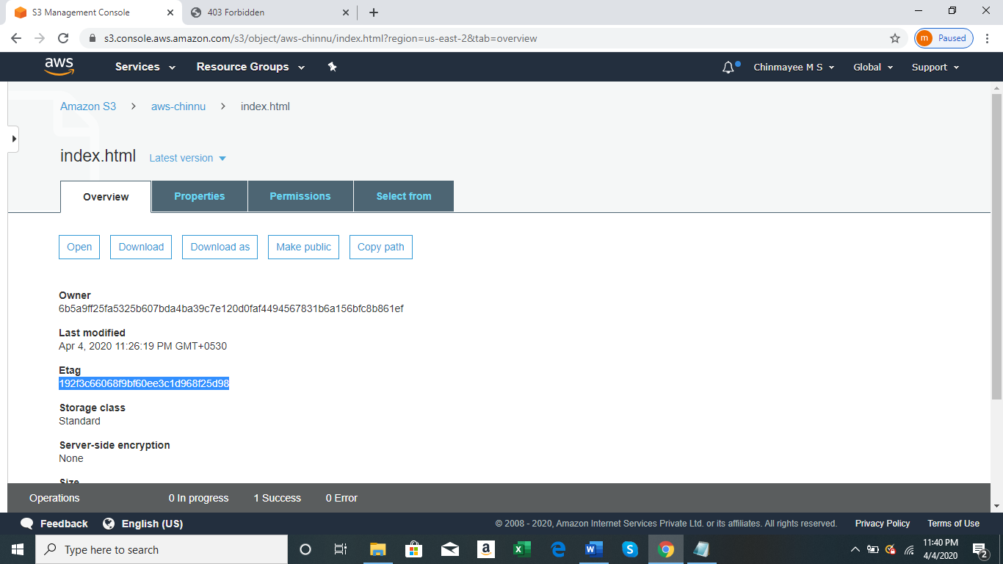

CHECKING THE S3 LINK ON THE BROWSER:-

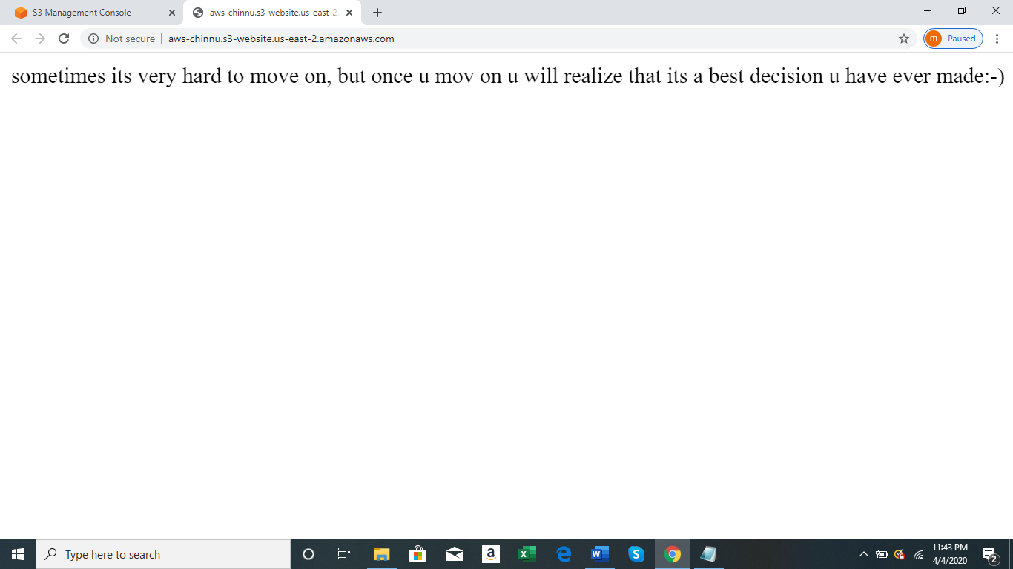

REKOGNITION

FACE DETECT:-

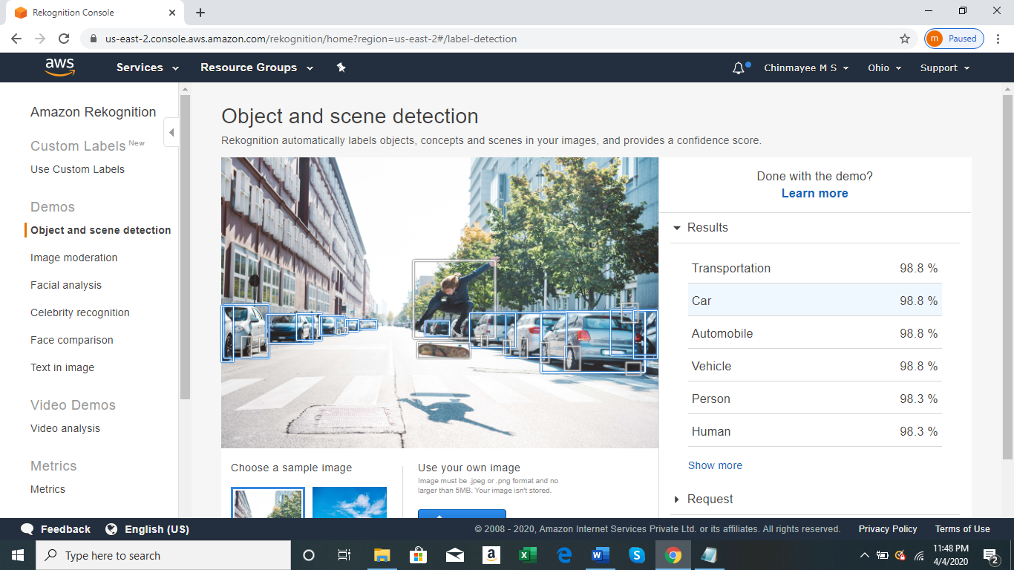

FACE COMPARE:-

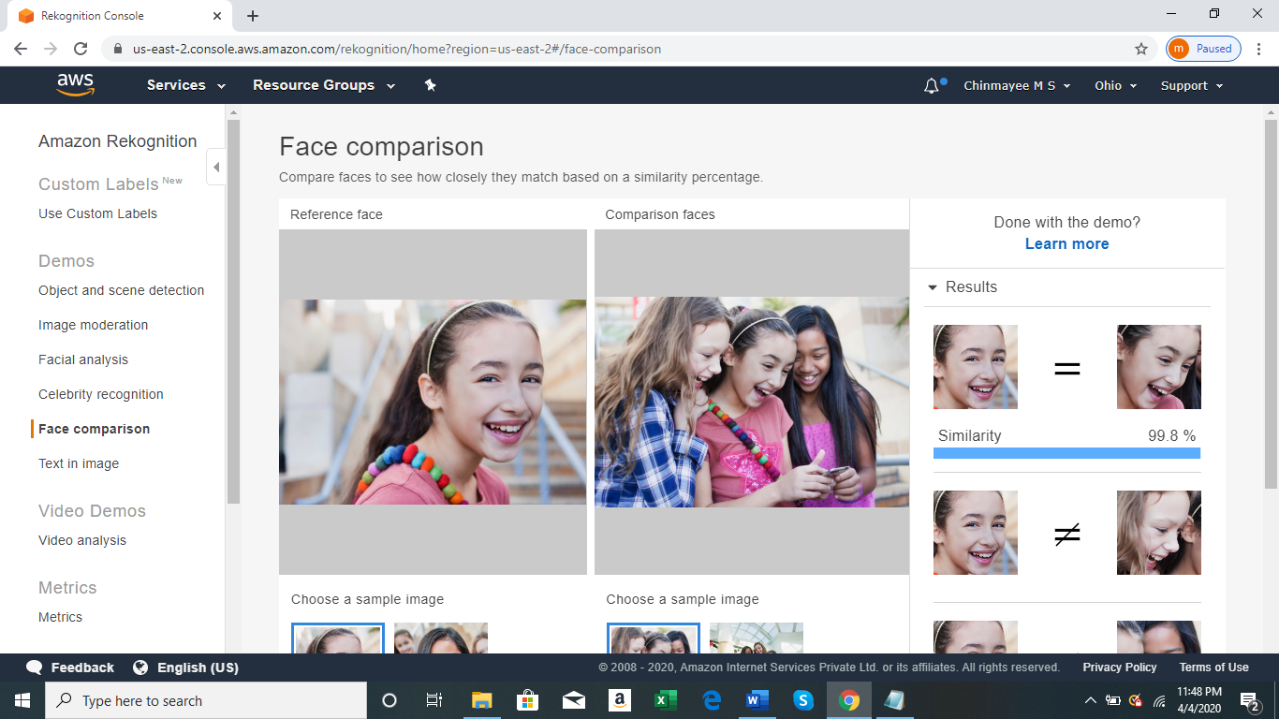

CELEBRITY RECOGNITION:-

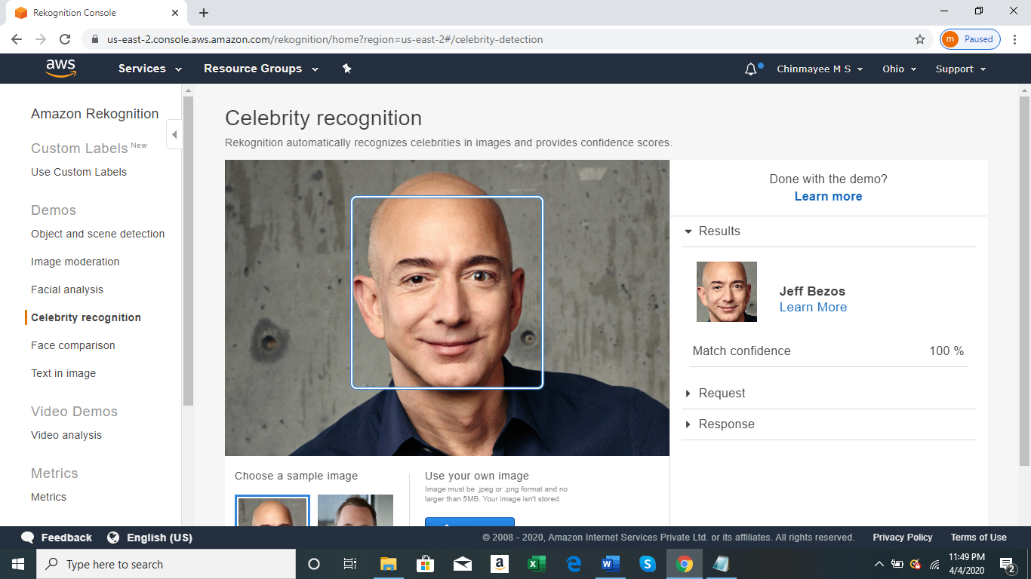

TEXT IN IMAGE:-

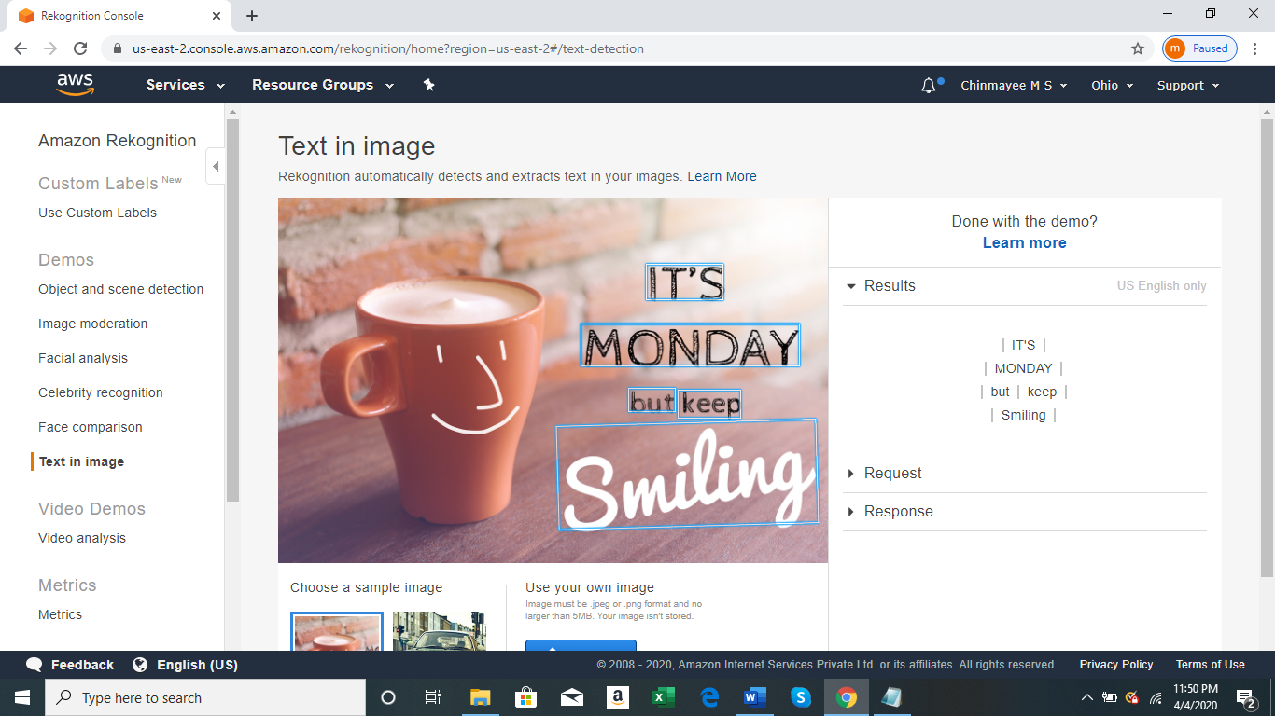

EC2 & S3

INSTALLING PHP:-

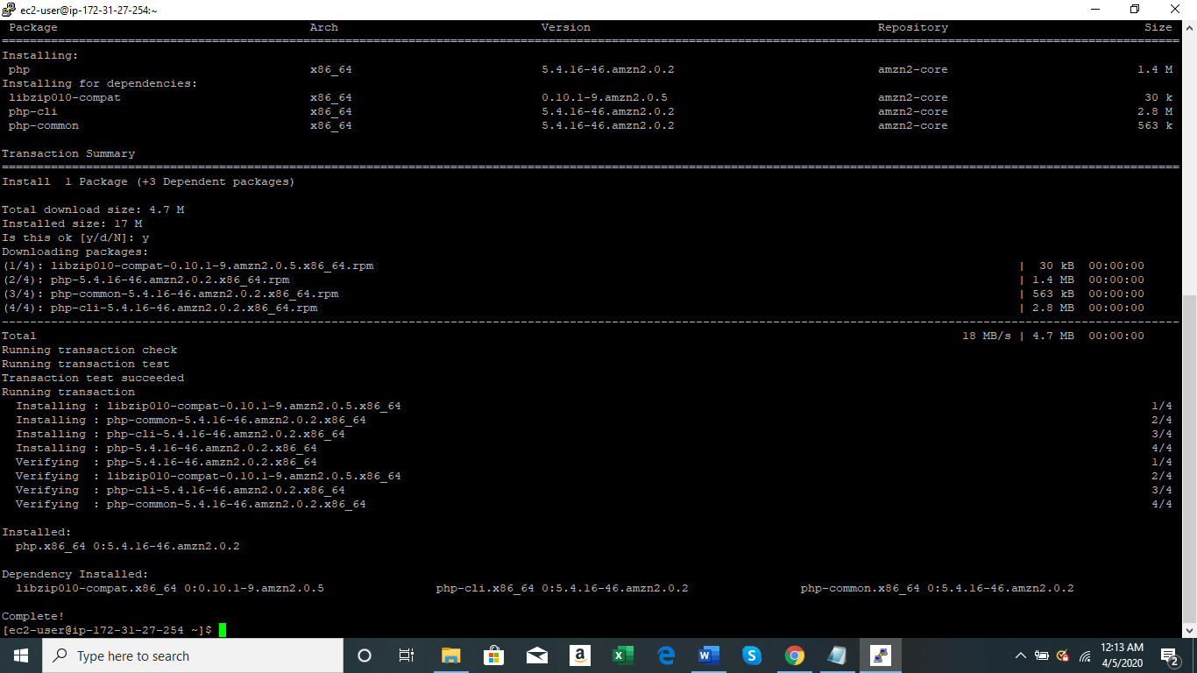

INSTALLING AWS-SDK:-

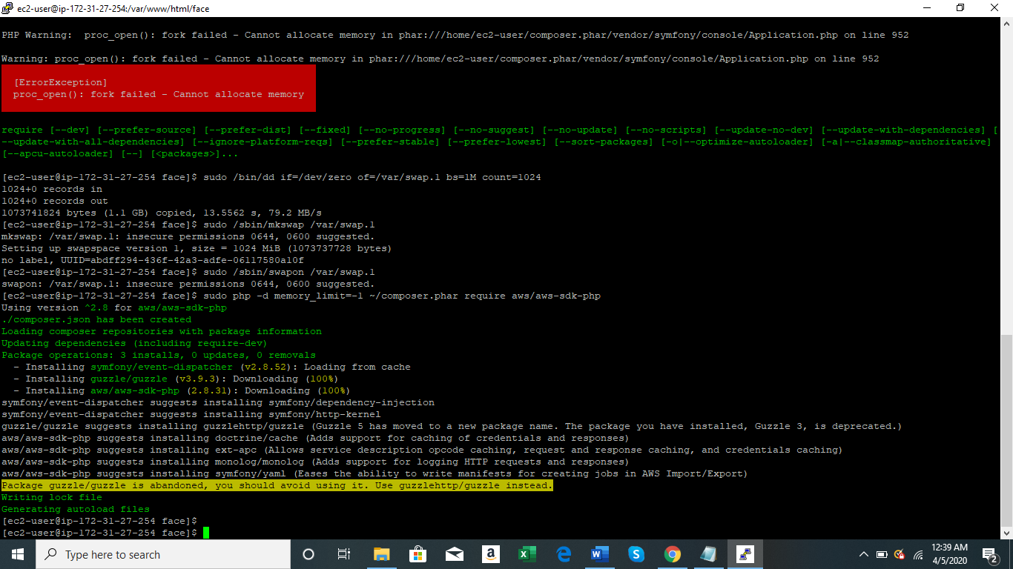

INDEX.PHP FILE CODE:-

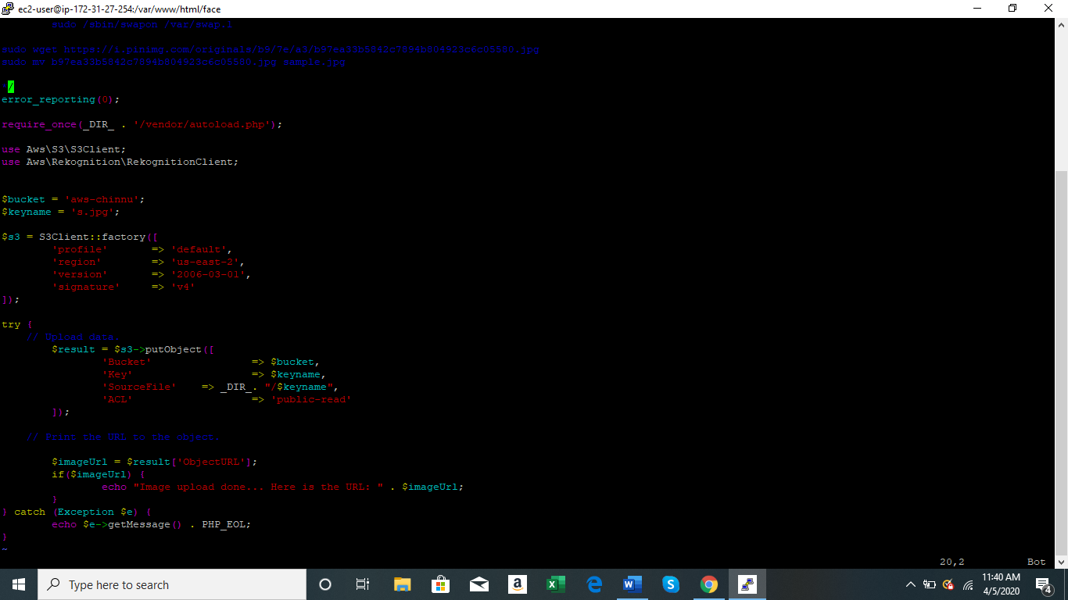

SUCCESS SCREENSHOT:-

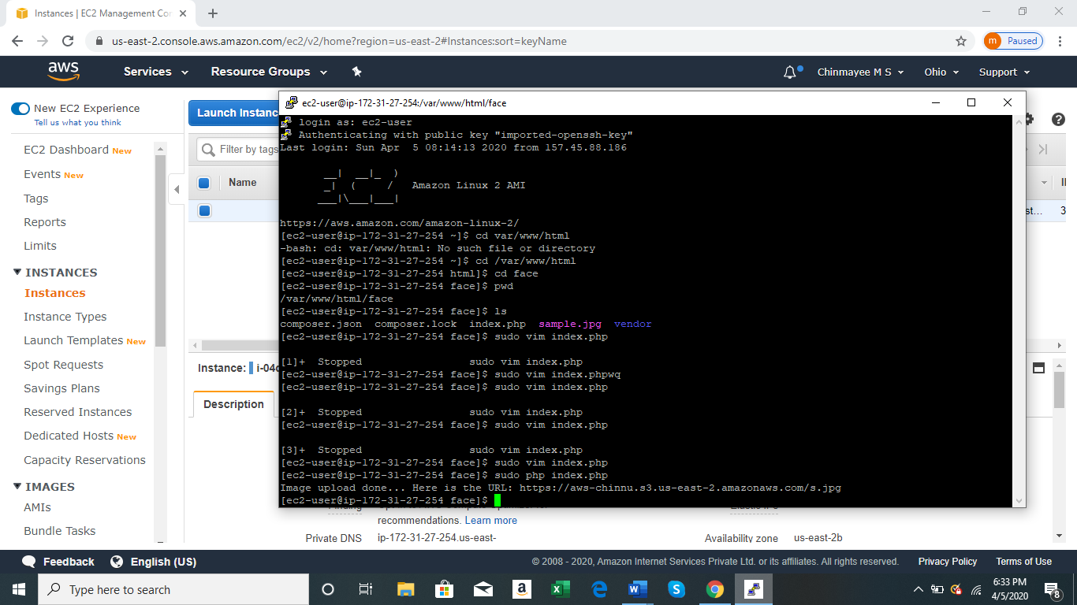

EC2-REKOGNITION

FACE DETECT SUCCESS SCREENSHOT:-

